Day 4 -Salesforce All-Star Ranger
Today, we are exploring the module called “Data Modeling”.
At first, we came across the Data Model, in layman’s terms, it is also called an Excel Sheet.
Excel Sheets consist of Tables, Rows, and Columns, which are also referred to as “Objects, Records, and Fields in the Sales terminology.
There are 2 types of Objects in Salesforce:
(i) Standard Objects like Accounts, Contacts, etc .&
(ii) Custom Objects: Which we create.
Today, I have gone through the different types of relationships in the module:
(i) Look Up Relationship
(ii) Master — Detail Relationship
(iii) Hierarchical Relationship → This is on the user object.
Look Up relationships are those where one object is a standalone object without the other one.
It can have One-to-One and One-to-Many relationships. In layman’s terms, to be discussed, it can have its own identity without dependency.
Ex: Accounts and Contacts
Master-Detail Relationships: These are highly dependent, and if we delete any master object record, all the associated detail object records are deleted.
Ex: Property and Offer, Exam and Scores, etc.
Task:
Create a Relationship with the Offer Object:
I have created 4 relationships as we have progressed further in this unit:
2 Master Detail Relationships with Offers and Favorites.
2 Look up relationships with User and Contact
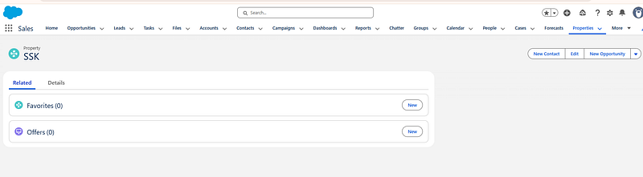Master — Detail Relationships in Salesforce
Later, we discussed something about the schema builder:
We can directly create or add objects and fields, it’s easy my personal opinion, but you need to have an idea of creating your records and objects.
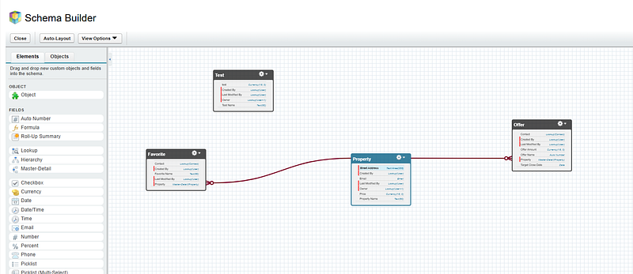
Later, as per my Trailhead, I have built a Data Model for a Recruiting App:
In this process of learning, I have come across the managed and unmanaged packages in Salesforce.
Managed packages are those where it is not like an open source, whereas unmanaged packages as in It’s like an open source, and can make customization changes as per the needs.

